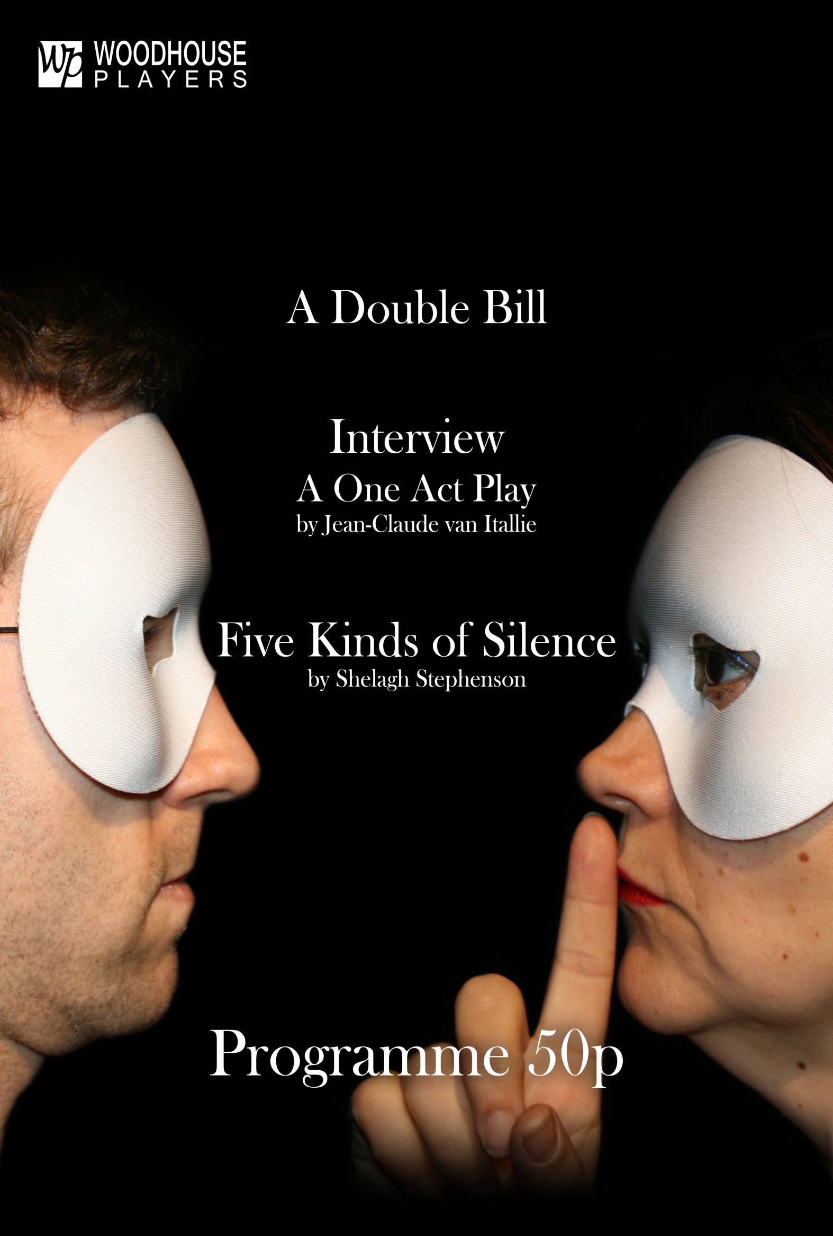

INTERVIEW

by
Jean-Claude van Itallie
First Interviewer Helen Thomas
First Applicant Tom Cannon
Second Applicant Michelle Hanks
Third Applicant James McKendrick
Fourth Applicant Elizabeth Braithwaite
Second Interviewer Chris Jefferies
Third Interviewer Jeannette Tucker
Fourth Interviewer Ian Powell

Music/sound Abbie Knowles

Director Gill Taylor
Choreographer Olive Stubbs

This amateur production of Interview is performed by arrangement with Josef Weinberger Ltd

INTERVAL

FIVE KINDS OF SILENCE

by
Shelagh Stephenson

Billy Phil Braithwaite
Mary Sharon Trotter
Janet Emily Zarate
Susan Rosalind Morris
Lawyer/PC/Detective William Barklam
Psychiatrist / Policewoman Cathy Love

Director Neil Bird

This amateur production of Five Kinds of Silence is performed by arrangement with Samuel French Ltd

DOUBLE BILL PRODUCTION TEAM

Stage Manager Anna Treadway
Assistant Stage Manager Stephen Wess
Lighting Kimber Wright
Sound Michael Brooks
Technical assistance/follow-spot Steve Wright
Front of House Manager Jenny Moorby
Box Office Phil and Liz Braithwaite
Poster/banner design Connor Cahill-Hayes
ACKNOWLEDGEMENTS

Special thanks to:

All those members of the Woodhouse Players who have given their time and assistance to this production, in particular those members of the cast and crew who have provided costumes and props and helped to build the set.

The Front of House helpers and cake-makers.

Our colleagues at, and other users of, the Welsh Church Hall: The Elders of the Welsh Church; Timothy Last, Caretaker; Sara Mulligan of Variations Dance Studio; Forest Baptist Church; Frances and Tom and all the team at Kidz R Us Nursery.

The Woodhouse Players gratefully acknowledge the support of:

Our Sponsors the Star of India, 875 High Road Leytonstone E11 1HR

Our Patrons: Derek Evans 2009 – 2013; Sue Gatward 2003 – 2016; Thos Ribbits 2003 – 2018; Russell Lines-Jobling 2016-2017

Getting Involved: If you would like to get involved with the Woodhouse Players (acting, technical, backstage, or just helping with serving teas and coffees to the audience!), please contact the Membership Secretary at members@woodhouseplayers.co.uk. Alternatively, you can support the group through our ‘Friends and Patrons’ scheme for as little as £20 per year – ask the Membership Secretary for more details.

The Woodhouse Players will perform both tonight’s plays at the Waltham Forest Festival of Theatre, which takes place from 16-21 March at Chingford Assembly Hall, Station Road E4 7EN. Five Kinds of Silence will perform at 7.30pm on Tuesday 17 March, Interview at 7.30pm on Friday 20 March. Full details of all the groups taking part and the plays being performed at the Festival are given on the website www.wffot.org.uk

Come along to support your local group and check out the work being done by other amateur companies in the area!



Interview - Director’s note

“We were discovering in the sixties that we had been lied to by the establishment in every way. Yet the very words we were being lied to with, still we had to use them to speak.”

Jean-Claude van Itallie


In 1965-66, a triple bill of three short plays by Jean-Claude van Itallie - Interview, TV and Motel (collectively entitled America Hurrah) - burst onto a New York theatre scene ruled by naturalistic, text-based plays and the “method”.

Method actors followed the teachings of Stanislavsky and his followers, which emphasized the practice of connecting to a character by drawing on personal emotions and memories. America Hurrah emerged out of the experimental, physical theatre of practitioners such as Joseph Chaikin and his Open Theatre who devised theatre pieces through improvisation and incorporated elements of music and dance into his plays. Chaikin believed that truths about life were more likely to emerge through movement, poetry, dream logic, intuition, and improvisation than via prose texts: "I’m not crazy about naturalism on stage. An actor is an interpretive artist. They can take their talent further. I wanted them to stretch, be creative." As another Open theatre collaborator said: "During the sixties we were concerned with stripping away. Chaikin and the Open Theater actors worked to reveal the actor's imagination as projected by the actor's presence. We showed that full, exciting theatrical productions could be done with nothing but actors and two benches or four chairs or only a bare stage. It was not only a matter of economics, it was essential to demonstrate the profound power of the actor's imagination and the actor's ability to create place; i.e. scenery through the power of belief via total technique and through the use of transformation not only of character but of time and place.”

Jean-Claude van Itallie was born in Belgium in 1936; his Jewish family fled to America in 1940 and he grew up in Great Neck, New York. He was one of the original playwrights at Ellen Stewart’s LaMama Experimental Theater Club, and main playwright with Joe Chaikin's Open Theater. He is the author of some 30 theatre works and has translated Chekhov's plays. Interview grew out of one of Open Theater’s exercises and was directed by Chaikin when America Hurrah opened at the Pocket Theatre in 1966.

America Hurrah went from its avant-garde Greenwich Village beginnings to mainstream success - Time magazine described it as“An off-Broadway trip through an air-conditioned blightmare towards an icy emptiness at the core of American life,” and it toured to the London’s Royal Court in 1967. Rarely performed nowadays, the plays have lost the shock value that caused threats of prosecution when they toured to Australia (in Motel, the last of the trilogy, two life-size puppets systematically trash a motel-room, scrawling obscenities on the walls, as the voice of the unseen motel owner describes its luxurious facilities). But the critique of modern society offered by Interview continues to strike a chord today, and the play’s surreal style continues to offer challenges and rewards to actors and audiences alike.

Gill Taylor
Director, Interview
Five Kinds of Silence - Director’s Note

Five Kinds of Silence is a powerful and poetic play telling the story of a family living under the power of the vicious Billy. It explores the ideas of abuse being continued from childhood; of how abused children may go on to abuse their own offspring; and of isolation from the outside world. It started life as a radio play, winning the 1996 UK Writers Guild's Best Original Play award and the 1997 Sony Award for Best Original Drama. The stage version was first performed in 2000 at the Lyric Hammersmith, with Tim Pigott-Smith as Billy.

Five Kinds of Silence has proved to be a popular choice for One Act Play festivals as it provides the actors with incredibly well written dialogue on a topic that is, tragically, always in the news. The piece is set in the 1980’s but does not date at all and could be set at any time in modern Britain with minimal change to the script.

I have deliberately stripped back all the peripherals such as set, sound, costumes, props etc as they add nothing to the piece. To me, Five Kinds of Silence is all about the story – or rather the stories –of the characters. These are so strong they deserve our entire focus. Each of the main characters are on a journey – with the parents we see how they became what they are and the childhood causes of their adult circumstances. With the children we see their journey out of the darkness to the light and to normality. But is their view of normality in step with ours . . . ?

I would like to take this opportunity to thank and applaud the cast for tackling such an emotive, tragic subject with such maturity and respect and for coming through it with their sanity intact.

Neil Bird
Director, Five Kinds of Silence

If you have been affected by the issues raised in Five Kinds of Silence, there are a number of organisations that offer further information and support both online and by telephone. These include:

The National Association for People Abused in Childhood (napac.org.uk)
Free helpline: 0808 801 0331

Women's Aid (www.womensaid.org.uk/):National charity working to end violence against women and children, co-ordinating and supporting domestic and sexual violence services across England
Free 24 hr National Domestic Violence Helpline 0808 2000 247

CAST AND CREW BIOGRAPHIES

William Barklam (Lawyer, PC, Detective, Five Kinds of Silence) first appeared at Woodhouse as Sir Robert Chiltern in An Ideal Husband in 2010. Since then he has acted in Blind Date, Honour, Bed and Glengarry Glen Ross, as well as appearing in many productions for a range of other groups across London.

Neil Bird (Director, Five Kinds of Silence) Neil’s first play with Woodhouse was Goodnight Desdemona (Good Morning Juliet) in 2012; since then he has appeared in The Oedipus Plays and as the Dame in this year’s Panto Hansel and Gretel. He also regularly performs with the Clavering Players, with whom he won the Best Actor Award for Joe in Goldfish Girl at the Cambridge and Welwyn Drama festivals last year.

Elizabeth Braithwaite (Fourth Applicant, Interview) has directed three one act plays for Woodhouse Players over the years, including Top Girls in 2004. She has also acted in many of the Double or Triple Bill productions. Previous roles include a bossy hospital matron, an incompetent barrister, a real-life East End matriarch and a librarian who was being three-timed by an interior decorator! Today she appears as a lady's maid, looking for but failing to find 14th Street!

Phil Braithwaite (Billy, Five Kinds of Silence) Fresh from assistant directing, producing and playing the child-squashing-pigeon-impersonating duck in Hansel and Gretel , and directing The Farndale Ladies in the Autumn, Phil is looking forward to playing the gentle and reserved Billy. Favourite previous one-act roles include Old Hamlet's Ghost in Hamlet Part II (2014), Isaac Newton in The Last of the Magicians (2007), Jenson and Hyde in Jenson and Hyde (2005), Baby in Kids (1999) and his début as Bro Paradock in A Resounding Tinkle (1994)

Michael Brooks (Sound) has many years experience with lighting and sound in a number of groups. He first joined Woodhouse Players for last years’ Triple Bill and has done sound on several shows since then.

Tom Cannon (First Applicant Interview) Tom first appeared at Woodhouse as Rudy in last year’s Bent, then spent January galloping around in search of his treasure as the Prince in Hansel and Gretel. However, having found that he couldn't shake the habit of spontaneously slapping his thigh, Tom realised he needed a more down-to-earth role on which to focus. Perhaps one where he got to wear overalls...

Michelle Hanks (Second Applicant, Interview) was last seen playing Thelma in our recent Farndale production. She was also a Ruffian in Compleat Female Stage Beauty. Michelle studied theatre at The University of Northern Colorado and The Denver Center National Theatre Conservatory and has acted in Denver, San Diego, and Prague. Some favourite roles include Beatrice in A View From The Bridge, Ata Windust in Criminal Hearts, Pooty in Reckless, and Kath in Entertaining Mr. Sloan.

Chris Jefferies (Second Interviewer, Interview) Having most recently acted in a variety of Shakespearean roles, Chris has enjoyed exploring the bizarre and truly modern world of Interview. Previous Woodhouse roles include Lord Goring in An Ideal Husband, Wilson in Ruffian On The Stair, and Verence in Carpe Jugulum.

Abbie Knowles (Music, Interview) This is Abbie’s first show with the Woodhouse Players, and she will soon be moving out of the music corner and onto the stage to appear in our production of The Tempest .

Cathy Love (Psychiatrist/Policewoman, Five Kinds of Silence) joined Woodhouse in 2007. Roles include The Landlady (Two), Mrs Cheveley (An Ideal Husband), Helga (Kindertransport), Mrs Drudge (The Real Inspector Hound), Marjorie (Bed), Jocasta (The Oedipus Plays) and most recently Lottie/Marty (The Haunted Through Lounge (etc) at Farndale Castle). She has directed Pantos, Pygmalion, What the Butler Saw , Bobby Gould in Hell (winner of Best Comedy at Waltham Forest Drama Festival) and Within Required Parameters (winner of Best Stage Presentation at Waltham Forest Drama Festival), and taken on many backstage and front-of-house roles. She has also performed with Network Theatre and the NatWest Theatre Company.

James McKendrick (Third Applicant, Interview) has appeared in many Woodhouse productions since joining in 2005, most recently as Levene in Glengarry Glen Ross and Jim Bank in The Acid Test . He has also directed Two and Bed, both by Jim Cartwright. He also acts and directs with Network Theatre and the Tower Theatre Company, recently appearing in Largo Desolato for Tower and directing Liz Lockhead’s Mary Queen of Scots Got Her Head Chopped Off for Network.

Jenny Moorby (Front-of-House Manager) has been a Woodie for some years now, playing a variety of mad old bats, from a retired opera singer in Daisy Pulls It Off to a race-horse-mad boarding house dweller in Separate Tables. On this occasion she will be running a mad old refreshment stall as Front of House Manager

Rosalind Morris, (Susan, Five Kinds of Silence) This is Ros' fourth appearance for Woodhouse. She was last seen as the French servant in Rope. Off stage she has operated sound for ''Allo Allo and Bent. Ros has also performed with Network Theatre.

Ian Powell (Fourth Interviewer, Interview) This is Ian's third appearance with Woodhouse, having played Herr Flick in 'Allo 'Allo and Hyde in Compleat Female Stage Beauty.

Olive Stubbs (Choreography, Interview) A University lecturer by profession, Olive has always been interested in dance and drama. She was a member of the Nonsuch and London Folk display teams for many years and now focusses on medieval drama in her work as Director of the Players of St Peter who perform extracts from the mystery play cycles every year at St George in the East, Shadwell.

Gill Taylor (Director, Interview) A Woodhouse member since 2008, Gill has directed her own translation of Anouilh's The Lark, Wilde's An Ideal Husband, Rattigan's Separate Tables and John Mortimer’s A Voyage Round My Father. Onstage roles include Granny Weatherwax (Carpe Jugulum) and Spinster (Bed). She appeared in the Old Vic/New Voices production Platform, and for the past three years has acted in the Players of St Peters’ annual Medieval Mystery Plays in Shadwell.

Helen Thomas (First Interviewer, Interview) featured in the Woodhouse productions of An Ideal Husband and Carpe Jugulum, before moving offstage to direct the one-act plays A Separate Peace and Hamlet Part II. She's pleased to be returning to the stage with violin and dancing shoes in tow.

Anna Treadway (Stage Manager) has spent over 10 Woodhouse years on stage or directing. She has chosen the least stage complex production for her first foray into stage management and enjoyed it so much she may even do it again.

Sharon Trotter (Mary, Five Kinds of Silence) has been a Woodhouse member for over seven years. She studied acting at City Lit where she played Mary in Memory of Water, also by Shelagh Stephenson, and appeared in Dark of the Moon and Jane Eyre. At Woodhouse she has enjoyed a variety of roles from peasants, panto chorus, dithery old ladies (Separate Tables) to murderous villainesses ( Carpe Jugulum and Pericles) . In 2012 she directed Honour by Joanna Murray Smith. For Network Theatre she assistant-directed Road by Jim Cartwright and appeared as Celia in Calendar Girls. She is a great fan of Shelagh Stephenson’s writing so is delighted to be playing Mary – probably her most challenging and thought-provoking role to date.

Jeannette Tucker (Third Interviewer, Interview) joined Woodhouse in 2011 to play grumpy waitress Mabel in Separate Tables. Since then she has appeared onstage in Carpe Jugulum, The Oedipus Plays and 2001 Arabian Nights, operated sound, assistant-directed Snow White and directed Compleat Female Stage Beauty.

Stephen Wess (Assistant Stage Manager) was a part of the Theatre Train youth theatre group, which included performances at the Royal Albert Hall. He is now a sound engineer with live music, fashion shows and corporate events. But he has always wanted to work within theatre surroundings so has found his way to the Woodhouse Players after seeing quite a few productions and wanting to be a part of it.

Lesley Winterflood (Producer) joined Woodhouse to play Sabrina the Witch in The Little Mermaid in 2007 and was last onstage playing the wicked Queen in Snow White in 2013. She has also produced, and run Front-of-House. Lesley has also appeared in a number of productions for Network Theatre.

Kimber Wright (Lighting) has appeared on stage - most recently in Snow White - and done a number of backstage and technical roles. Over the past year she has designed lighting for Bent, Compleat Female Stage Beauty, Farndale, and Hansel and Gretel.

Steve Wright (Technical Assistance/Follow spot operation) has appeared onstage (usually wearing chain mail) in Babes In The Wood, Carpe Jugulum and Snow White, but is more often seen up a ladder doing things with lights or single-handedly moving unfeasibly large bits of set.

Emily Zarate (Janet, Five kinds of Silence) is 24 and originally from Brighton. After graduating from Queen Mary University, where she also acted and did a university TV series, with a degree in History and Comparative Literature, she is currently working in a primary school in Hoxton.

COMING SOON FROM THE WOODHOUSE PLAYERS

 | The Tempest  by  William Shakespeare  Fri 22nd May 8pm  Sat 23rd May 2.30pm & 8pm  Fri 29th May 8pm  Sat 30th May 2.30pm & 8pm
The wrongly-deposed Duke of Milan Prospero causes a storm that shipwrecks a crew upon his island. Amongst those present are his sworn enemies, Alonso, King of Naples, and his brother Antonio. Prospero plots to wreak vengeance on the crew with the aid of his magic art, and takes the King's son prisoner. Meanwhile, his monstrous servant Caliban plots to kill Prospero and take the island for his own.
William Shakespeare's fantastical play is brought to life by the Woodhouse Players, in a magical production about revenge and reconciliation.

 | Chamber Piece  by Caroline Bird  Fri 10th July 8pm  Sat 11th July 2.30pm & 8pm  Wed 15th July 8pm  Fri 17th July 8pm  Sat 18th July 2.30pm & 8pm
Set a few years in our future, Britain has re-instated the death penalty and 'irredeemable' Richard Sanger's time is up. Now his brother, the victim's twin sister, a journalist and a 'spiritual advisor' are all here to watch him die. But behind the drapes of the execution room, everything hasn't quite gone to plan. This pitch black comedy by Caroline Bird looks at the death penalty in the ultimate 'British' way - with lots of paperwork and biscuits.

Please be aware that this play contains very strong language and strong themes of rape, and is not suitable for children or those of a sensitive nature.

Both at the Welsh Church Hall 881 High Road Leytonstone E11 1HR

Full details at www.woodhouseplayers.co.uk


www.facebook.com/woodhouseplayers www.twitter.com/woodhouseplays

